**Artsy Chaos**

**Soumi Chakraborty**

Engineering Science, IIT Hyderabad

This project attempts to put the chaos theory to work and create visual art by the means of a chaotic system.

1. **INTRODUCTION**

Chaos is often defined as complete disorder and confusion. It’s the inherent unpredictability in the behavior of a complex natural system. And yet, the Chaos Theory manages to find order in chaos.

The theory, often called the Butterfly Effect, essentially states that chaotic systems are in fact like regular systems but are highly sensitive to starting conditions. Even the smallest of changes in the beginning conditions would result in wildly different outcomes, giving the impression of a chaotic system.

A double pendulum set up is such a system and is very commonly used to demonstrate and explain the nature of chaotic systems.



In the final project, I have made use of a triple pendulum-like system to create art.

1. **CHAOS THEORY IN ART**

The chaos theory has been used in art forms before, albeit inadvertently in some cases. Dean Wilcox’s paper on [**“What does chaos theory have to do with art?”**](https://www.researchgate.net/publication/265705060_What_does_Chaos_Theory_have_to_do_with_Art) analyses and provides an interesting outlook on how this theory mixes with art, though Wilcox chose to use music as his artform.

Another article I stumbled upon while looking for instances of chaos theory talks about fractals (beautiful but random patterns that keep repeating to make a larger pattern) and how it is associated with the theory. A snippet from the article, written by Steev Morgan -

Chaos theory is the study of simple iterative formulae that produce complex, unpredictable results. In common usage the word “chaos” implies disorder or randomness but this sense it means an underlying, unpredictable order from which patterns emerge over time.

Those patterns are called fractals and they have a number of special attributes which make them different from Euclidean geometrical shapes.

One unique aspect is that their borders are infinitely convoluted, so that it is impossible to predict if points in the vicinity are inside or outside of the shape. This complexity means that fractals occupy fractional dimensions (they can occupy a dimensionality between 2 and 3D for example) (Burger/Starbird 507).

Fractals also demonstrate self-similarity at different scales. Patterns may be contiguous or have many elements that are not connected. Their patterns display infinite with infinite differentiation.

The equations that create fractals do not generate patterns in a linear fashion, as in Euclidean geometry where adjacent points are determined successively. Patterns emerge chaotically, so that it is impossible to predetermine if subsequent iterations will generate points which will fall within the shape or not. The final outcome of many iterations is radically affected by tiny changes in the initial conditions.

1. **MOTIVATION AND OBJECTIVE**

I chose to base my creative piece on the chaos theory because I’ve always been fascinated by the concept of the fact that nothing in this universe is truly chaotic. All systems which appear to be chaotic are in fact regular systems which are highly sensitive towards beginning conditions. What this effectively implies is that even if the system repeats a certain set of movements or paths as closely as possible, the resting outcomes are going to be very different each time.

To create my painting, I tried to unify science with art - the science part of it being the application of chaos theory. The driving idea was to use a triple pendulum (a very chaotic system) to make a collection of monocoloured patterns on the same canvas sheet, but because of the highly chaotic nature of the chosen system, no two patterns will look even remotely alike, giving the final painting a very abstract appearance.

Also, the idea of using a pendulum to create a painting struck me because of a [YouTube video](https://www.youtube.com/watch?v=uPbzhxYTioM) I watched a couple of years ago which had cropped up in my recommendations.

1. **METHOD**

The set up of my project consisted of a regular double pendulum, which had a paint-depositing mechanism attached below it, thereby acting like a triple pendulum.

I shall now proceed to illustrate the steps I followed to create my final piece:

1. **Materials**
   * 3 canvas boards
   * Oil paints
   * Parts of a double pendulum
2. **Stage one: Making a simple pendulum**

I started off by making a simple pendulum. I did so by suspending a bar from a support, such that it pivots around its top end.

1. **Stage two: Making a double pendulum**

I made a double pendulum by pivoting a second bar on the bottom edge of the simple pendulum. This double pendulum is the first chaotic system involved in my process.

1. **Stage three: Making a triple pendulum**

The double pendulum was converted to a triple pendulum. To do so, I suspended a paint-containing cup from the lower edge of the bottom bar of the double pendulum with the help of some yarn. As this system is now triple-jointed, it effectively acts like a triple pendulum - a highly chaotic system.

1. **Stage four: Placing canvas boards**

I arranged the three canvas boards in aesthetically-pleasing orientations under the triple pendulum set up, such that majority of the paint from the cup would drip onto the canvas.

1. **Stage four: Setting the system in motion**

This step is where the actual painting started. I filled the cup up with paint (a shade at a time), punched a small hole in the bottom of the cup, and set it swinging over the canvas.  
The paint dripped onto the canvas and formed arbitrary patterns in accordance with the motion of the simple pendulum.

1. **Stage five: Repeating step 6**

I repeated the previous step multiple times, each time with a different shade of colour. The following colours were used in the order they’re being listed in:

1. Brown
2. Green
3. Sky Blue
4. Purple
5. Red
6. Yellow
7. **Stage six: Finishing up**

The paint-soaked canvas was then left to dry over a course of three days. I added a few final touches by splashing the canvas with a few drops of brighter colours to make it look slightly more artistic.

The final product was a very abstract looking piece of art.

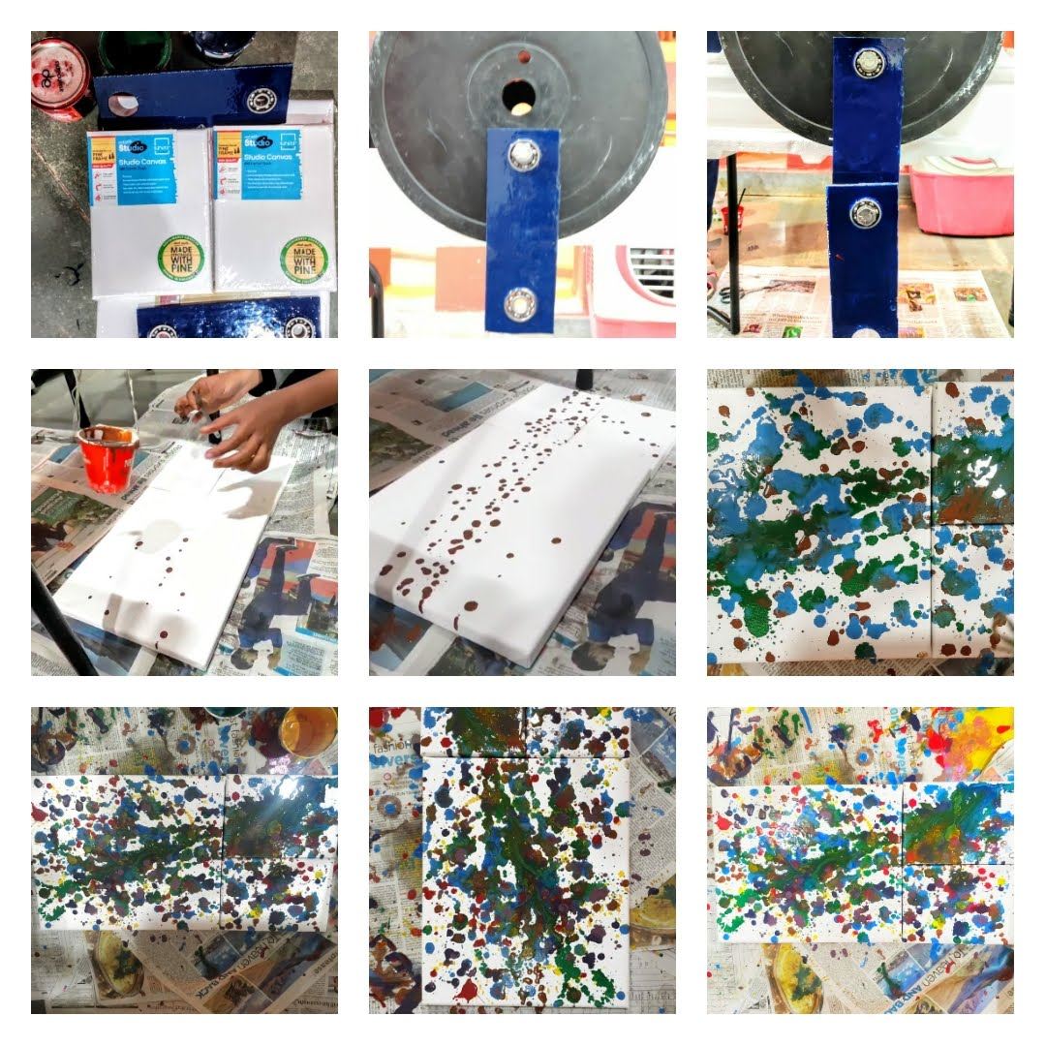

1. **RESULT AND CONCLUSION**

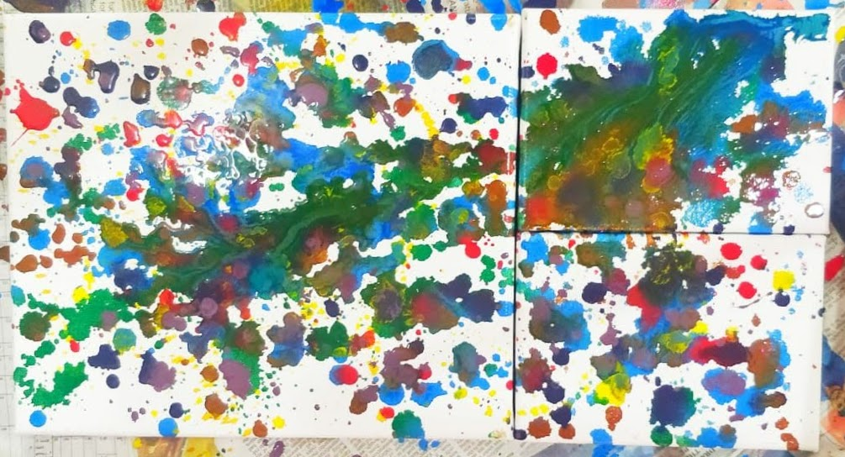

The final art-piece resulted from the motion of a very chaotic system. As mentioned earlier, chaotic systems appear to behave erratically since they are highly sensitive to starting conditions. Hence, even though I used the same set up to drop paint on the canvas each time I changed colours, the resulting patterns were all wildly different from each other.

Thus, the abstract-nature of the final painting effectively depicts the randomness in the behaviour of the triple pendulum.

1. **REFERENCES**
2. [“What is Chaos Theory?”](https://fractalfoundation.org/resources/what-is-chaos-theory/) - *Jonathan Wolfe, Julie Tyrrell*
3. [“What does chaos theory have to do with art?”](https://www.researchgate.net/publication/265705060_What_does_Chaos_Theory_have_to_do_with_Art) - *Dean Wilcox, 1966*
4. [“Applying Chaos Theory to Artistic and Cultural Practice”](https://steev.ca/chaos-in-art-and-cultural-practice/) - *Steev Morgan*
5. [Sand pendulums - Lissajous patterns](https://www.youtube.com/watch?v=uPbzhxYTioM) - YouTube video